Task-3
PWD – present working directory

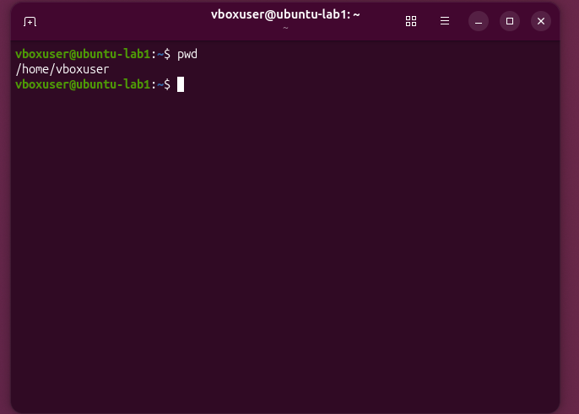

ls - list
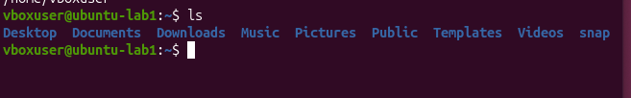

ll
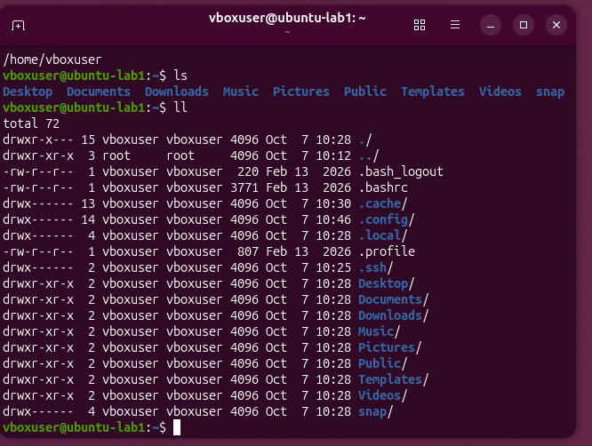

ls -a
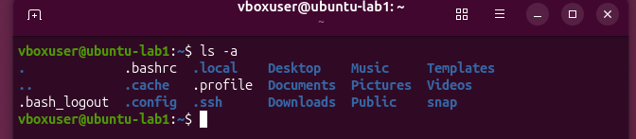
Mkdir
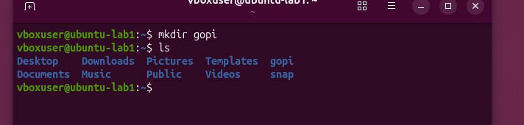

Mv move to hidden
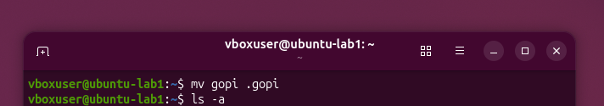

Mv to move from hidden
History
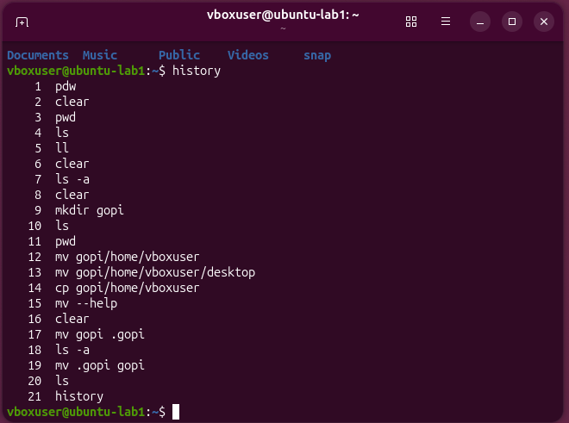

Delete
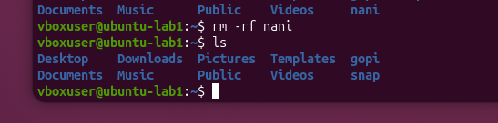
Cd desktop

cd ..

To change location
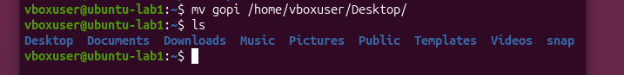
File

To copy all the directorys in file

Create a file in side the file

To write in the file
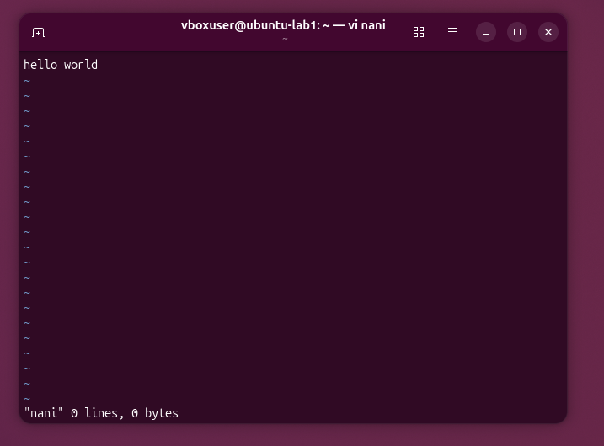

To save
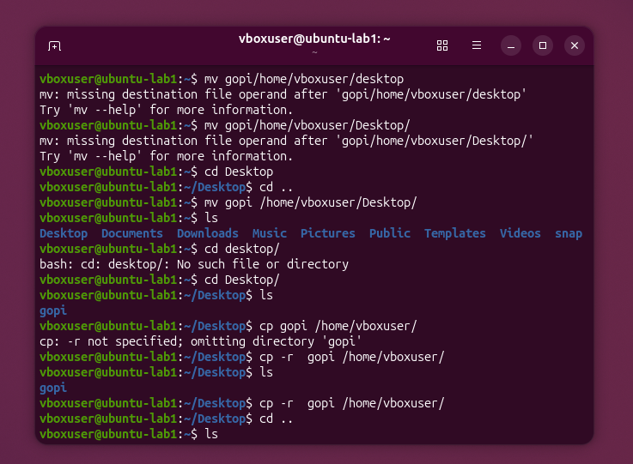

To read
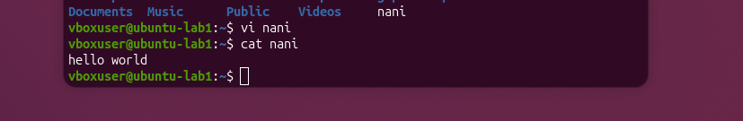
To delete
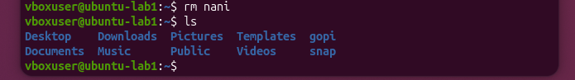
WC to get in detail


